

Western University Faculty of Engineering

Studio Section 19 – Dr. Charpentier

Team Identifier: S19P2A

Team Members: Omran Amin, Yicun Guo, Tim Kerkhoff, Arjayn Piratheeparatnam, Tyler Wade

Team Report 4: House Framing

Mobile wall panel assembly station for residential housing.

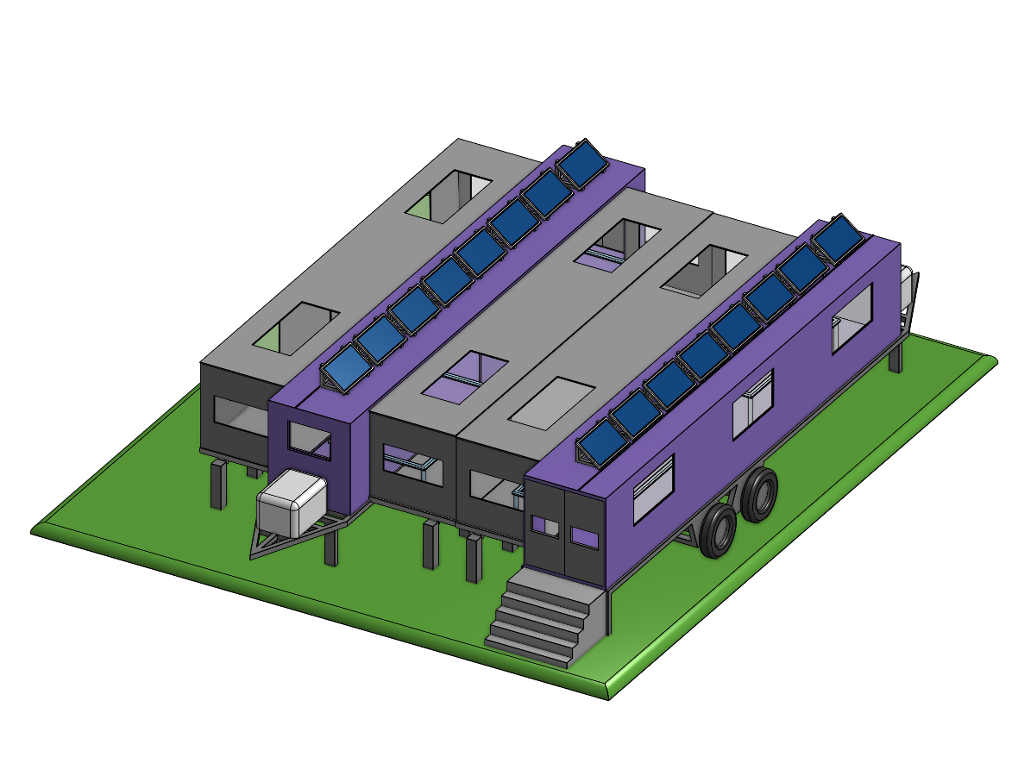

Need / Challenge

Home builders and contractors need a way to frame and construct houses in order to minimize the amount of waste material produced on residential construction sites, while establishing a method that encourages environmentally friendly practices and high-quality output, because the current method has a lot of material wastage, low quality framing and logistical difficulties in assembling the frames.

# Final Design Documentation

## Intro

Our final design seeks to combine the geographical convenience of constructing wall panels on-site with the optimized assembly process used when preassembling wall panels in an offsite plant. Assembling the site panels allows for specialized machinery and an assembly line process to produce wall panels. However, it requires the wall panels to be transported to the construction site. Our design allows the plant style assembly method to be used on site, combining the most desirable aspects of each method.

## Overview

The final design consists of two specialized, 53’ cargo container trailers parked side by side to contain the assembly process and is shown in Figure 1. The trailers have been modified with additional floor, wall and roof panels that fold outwards to expand the footprint, providing the necessary space for the assembly process. The wall and roof panels are made of aluminum because it is lightweight and robust, making it easier for the crew to expand and collapse the trailers. The floor is made up of the same steel panels as the containers and is fitted with support legs. Having the wall panels helps protect the workers from the elements, allows the station to be securely stored overnight, and supports the roof sections. The trailers are fitted with removable stairs for worker access, and each has several supports that extend from the trailer, mainly to bear the load carried by the extended floor sections. An additional top down section view with dimensions of the interior is also provided in Appendix A.

For further viewing of the 3D model please use the following OnShape link: [https://cad.onshape.com](https://cad.onshape.com/documents/6ca297f60f23604767a1ad78/w/82f7b09991c712c765c2c902/e/3fe58ab332cb646dca118c67)

Figure 1: Mobile Framing Station

The trailers are equipped with solar panels to provide electricity for the machinery and the trailers' lights. The trailers are equipped with battery storage mounted on the front of the trailers, which could also be replaced with a generator, or the trailers can be connected to an external power supply. Several windows have been added to provide natural light during the day, reducing the energy demand and improving the work environment. Select windows will open to improve ventilation further. To meet safety regulations, the necessary fire extinguishers and exit signs are installed in the critical areas.

The station is not insulated, so the workers are responsible for dressing warm enough during the winter months, but the station is weatherproof. The seams where the expandable panels meet will be lined with a rubber sealing liner to prevent rain or snow from getting in. During harsh weather, the loading platform can be enclosed when panels are not picked up, as shown in Figure 1. Both exterior wall panels can be opened or closed independently as needed.

## Trailer A

Figure 2: Trailer A

Trailer A contains both the first the last step of the process of the entire design. The trailer has wood storage for wood supplies to be deposited for getting made to house frames, and it includes a loading station for the finished house frames to be shipped and used. In addition to that, the trailer has a wood cutting station to get the wood to the correct dimensions for assembly. To reduce the cutting machine's noise, we installed sound dampening materials on the wall to eliminate as much noise as possible.

The trailer has two of the main parts of the assembly process. Right beside the cutting station and wood storage would be the first framing table that would assemble the window and the door openings for the wall panels. The last framing table in the process would be near the loading zone. That table would be responsible for adding structural sheeting to the house frames, and between the two tables is the sheeting storage that would contain all the sheets.

## Trailer B

Figure 3: Trailer B

Trailer B contains the intermediary steps of the assembly process of the house frames. The sub-assembly and final assembly process take place in this trailer across two framing tables. One framing table is used in assembling the doors and windows of the house frames. The following table would be for the final assembly, for assembling the perimeter and the surrounding studs of the windows and doors. In this step, there is also some final checking on the frame to ensure it is in the perfect shape condition that it needs to be in.

## Production Process

Figure 4: Assembly Station in Operational Configuration

Once the trailers are at the job site, they will need to be set up for operations. To do so, Trailer A will first be parked in the desired location. Using the still collapsed Trailer A as a reference, Trailer B will be parked to the left and facing the opposite direction as Trailer A, 18’ apart. For convenience, an 18’ rope will be stored withing the trailers to easily mark out the position of Trailer B, relative to trailer A. Figure 7 shows how the assembly station will be collapsed for relocation, and the process of setting it up would be identical but in the reverse order.

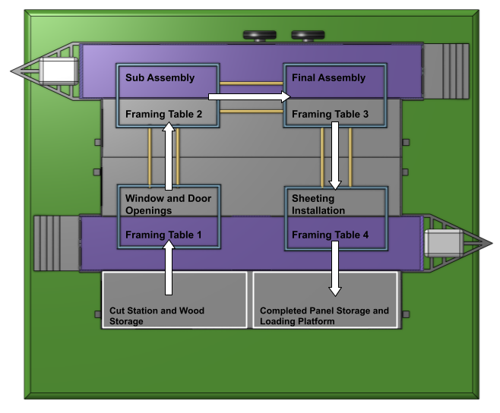

Figure 5: Overhead Sectional View of Assembly Process

Figure 5 shows an overhead layout of the assembly process. The production begins in the Cut Station, which also houses the wood storage system. The cut station will include a table saw and mitre saw to cut all the necessary pieces for panel assembly. From there, the pieces move to the first framing table, where the windows and door openings are assembled. The initial assembly then slides on rollers to the second framing table for the sub-assembly, where wall studs are added to the frame. The third framing table completes the assembly by adding the top and bottom plates. The frame then moves to the last framing table, where structural wall sheeting is installed; afterwards, it is moved to the loading platform where completed panels can be stored until they are picked up and transported to the house using a telehandler.

## Relocation

After completing a residential neighbourhood, the client will move the assembly station to the subsequent residential development. When being transported, the trailers will fold up, as shown in Figure 6. The framing tables are adjustable to suit different wall panel sizes and retracted to their most miniature settings to fit within the trailers. The removable steps will also be stored within the trailers. Because the client will have just completed a neighbourhood, they will not have a large number of materials on hand or an excess of completed frames. However, the trailers will be able to accommodate a small amount of remaining material and frames during relocation.

Figure 6: Assembly Station in Transport Configuration

Figure 7 shows a step-by-step process of collapsing the expandable panels to transport the two trailers to the following job site. The exact process will be completed but in reverse order when setting up the assembly station. The trailers will be towed by two semi-trucks owned by the client, or if they only need to be moved a short distance, one truck may be used to make two trips.

Figure 7: Assembly Station Take Down Process

# Testing and Validation

## Objectives (and Functional Capabilities)

*Table 1: Objective Testing and Validation*

|  |  |  |
| --- | --- | --- |
| **Objective** | **Assessment** | **Evidence** |
| Maximize efficiency in time taken to construct a frame | Exceeded | When framing, structures can move freely on the rollers instead of people walk around structures. At the same time, the nail gun can slide along a fixed track. This reduces the time it takes for workers to aim and hit the nail. These optimized processes have saved more than 50% of the time for workers to drive nails. Finally, when a part of the work is completed, the workers can easily move the assembled structure to another table with different functions through the rollers. This reduces lifting and handling time by 60%. |
| Lower overall costs | Exceeded | Two people are enough to operate the facilities in these two trailers, which is more than half less than the people required on a traditional construction site. At the same time, the time required for framing has been reduced by nearly half. Thus, the labour cosets are greatly saved. Inside the trailer, there is also a section for storing the cut wood, and these smaller pieces of lumber can be used in another framing process. This reduces waste and saves raw material costs by 30 percent. |
| Reduce environmental impact | Exceeded | Because workers can frame structures on-site, they no longer need to transport vast and low-density pre-assembled structures over long distances. They only need to transport the tightly packed lumber to the work area. This saves transportation vehicles’ carbon emissions by 40% during transportation. Furthermore, as mentioned above, recycling and reuse of wood are added to the work process, which reduces material waste by 60%. |
| Easy to use | Exceeded | The easy to use of this design is reflected in two aspects. First, this is a working platform that is precisely levelled. It is much easier to maintain high precision in assembly than on the ground. Second, works can use a nail gun fixed on the slide in the trailer instead of hitting the nail with a hammer. They can also move the structure on the roller with much less force than lifting and moving the structure. All of these make works working easier and faster. |
| Improved quality | Exceeded | Because this is a flat and high-precision platform, such as nail guns and circular saws, they are installed on a track or cantilever arm with a designed angle and position. This can further improve accuracy and reduce human error. |
| Use standard sawn lumber sizes | Exceeded | The platform in the trailer is designed to use standard sawn lumber, but a recycling area is also designed for the inevitably leftover material generated using fixed-size wood. |

## Testing and Validation: Constraints

*Table 2: Constraint Testing and Validation*

|  |  |  |
| --- | --- | --- |
| **Constraint  (with Units)** | **Importance / Implications** | **Assessment and Evidence (Met / Not met)** |
| 20-25 minutes to fully assemble frame | The current on-site method takes 30-45 minutes depending on the skill of the crew. [1] | Test – Throughout one day of use, the number of frames produced, and total operating time can be recorded and used to calculate the average for one frame to be assembled and comparted to the constraint.  Met – projected assembly time would be comparable to the plant assembly method of 10-15 minutes. [1] |
| Wasted material is less than 10% of material used | The client expressed how onsite material management was non-existent, increasing costs unnecessarily. [1] | Test – After receiving a shipment of wood, any discarded material can be kept in a waste bin in the cut station. Once all of the wood has been used, the amount of wood in the wase can be weighed and than compared to the weight of the initial shipment of wood to determine the percent of material that was wasted.  Met – the use of the designated cut station and improved material storage will help eliminate waste and maximise the used materials from a length of wood by saving the excess length from a cut until another length can be cut from it. |
| Less than 10,000 SQ FT | The average lot size ranges from 7000-10000 SQ FT. The assembly station will likely be set up on an empty lot being used for other equipment or material storage in the neighbourhood. [1] | Test – Measure the length and width of the assembly station when fully expanded for operations and compare to the constraint.  Met – the final design can be operational on less than 4000 SQ FT and should have no issues finding adequate space to be set up. |
| Can be taken down, transported, and set up in less than 10 hours. | The client expressed their desire to be able to relocate the framing station in one day. [1]  This constraint is subject to the distance between construction sites, but the client will be using this station in south western Ontario and will not be relocating overly far away. | Test – After training the crew to set up and take down the station, the crew can be timed while they relocate and compare to the constraint.  Undetermined – It is not certain that the framing station will be able to be relocated within a day based on the CAD model and diagrams alone. Closing the extendable panels should not take long, but we are unsure of the difficulties or logistics required to store the Panels Plus framing tables for transportation. So long as the station can be folded up as planned, transporting the two trailers would be the same as a normal semi truck and trailer. |
| For every 1000 frames produced, no more than one frame is unusable due to error when assembling. | The current on-site method does not allow the frames to be precise. They are assembled free hand on the ground. This introduces error from the crew assembling them as well as if the surface is not completely flat. [1] | Test – After training the crew to use the new assembly method, a tally of frames completed, and unusable frames can be recorded and compared to the constraint target.  Met – the use of the Panels Plus tables remove both sources of error, by providing a consistent framing surface and can be configured to the exact dimensions. Like a template, the worker can just lay the pieces onto the table without needing to measure each time. |
| Walls can support 2.4kPa | Sacrificing load bearing capacity will result in unusable wall panels. | Test – Several completed wall panels can undergo compressive loading tests to determine their critical strengths.  Met – Walls are still being assembled with same material using the same design, so load bearing capacity has not been changed. The increased precision of the panels plus tables has likely improved it. |

# Comparison

## Comparison 1

On-site Framing Method – Status Quo

|  |  |
| --- | --- |
| Practicality Comparison | The status quo method of house framing that the client currently employs onto their worksite is practical but time consuming and has a lot of possibility for framing errors and inefficiencies. This method is the most familiar to the average trained worker on a worksite since the learning curve is much easier. |
| Comparison of Strengths | The strengths of this method are that it is easy to implement onto the worksite since there would be enough space to adequately fit all materials to frame the house. Whereas the suggested solution would take a bit more space to do the same task. |
| Comparison of Weaknesses | A weakness of this method is that there is a larger margin of error since the workers themselves have the possibility to measure items wrong and, place them inaccurately together. The suggested solution eliminated this weakness or at least reduces the possibility of it occurring as frequently. |
| Other Comparisons | The suggested solution aims to increase the efficiency of the process and reduce the material wastage involved in the framing process. |

## Comparison 2

Off-Site Plant Panel Assembly Method – Existing Market Solution

|  |  |
| --- | --- |
| Practicality Comparison | The comparison between the suggested solution and off-site assembling are similar because the same machinery is used, so the framing accuracy would be the same. |
| Comparison of Strengths | Both options are very efficient methods that help save time, money and resources. |
| Comparison of Weaknesses | The weakness of the offsite panel assembly method is that the plants are usually great distances away from the worksite so there are logistical difficulties and costs that accrue when having to ship the panels from the plant to the site. There is also the ability of the frames to possibly break or have deteriorated structural integrity from the way that they are shipped to the worksite. The suggested solution would eliminate this possibility entirely since there would be no need to ship the frames. |
| Other Comparisons | The suggested solution would implement the market solution assembly method but would require more space to be used when implemented on the worksite whereas the plant is a dedicated space to house the machinery. |

# Potential Improvements

As a team, we feel confident and satisfied with the outcome of our design. We believe that we have created a solution that addresses our clients’ primary concerns. However, if our team were to be given more time or had an opportunity to do this project repeatedly, a few aspects of our design could be improved. Our current design has a security system on our trailer to avoid any potential theft during overnight storage. However, there are other security measures that we could implement as either an addition or an alternate. Most construction companies use construction site CCTV monitoring as well as live monitoring. These cameras are known to be more cost-effective and reliable. However, they encourage others to add other security measures to their site in order for it to be more effective. For instance, we could implement tall fences that surround the trailer to refrain intruders from climbing over. If they were to try and climb over the fence, the construction site video monitoring company would be alerted instantly. Displaying “no trespassing” signs across the fence would legally protect the construction site from any intrusion. A different security measure that can be used is adding lights around the construction site with motion detection. This would help raise awareness from the live monitors and notify the company faster.

To further improve the design. We can explore and experiment with other layouts to identify the most effective method. The initial layout did not change too much but experimenting with a linear assembly station where the two trailers are parked end to end could be interesting. Another option would be to explore other platforms instead of the cargo container trailers.

If we were to continue developing our mobile assembly station, these would be the ideas that we would consider. Throughout our Winter Project, our team worked well with each other. We were able to collectively create ideas that would best suit our project based on the information we received from our client meeting. We completed our team assignments on time, negated any procrastination from occurring, and received encouraging feedback. However, if there was one thing that we could improve, we believe it could have been our communication. We should focus on arranging meetings during the week as soon as possible to avoid others from not being able to attend due to prior commitments. Otherwise, we all equally made an input throughout our Winter Project, and we are all looking forward to presenting our design.

# References

|  |  |
| --- | --- |
| [1] | G. Hussey, Interviewee, *First Client Meeting for Project 2 - House Framing.* [Interview]. 29 January 2021. |

# Appendix A

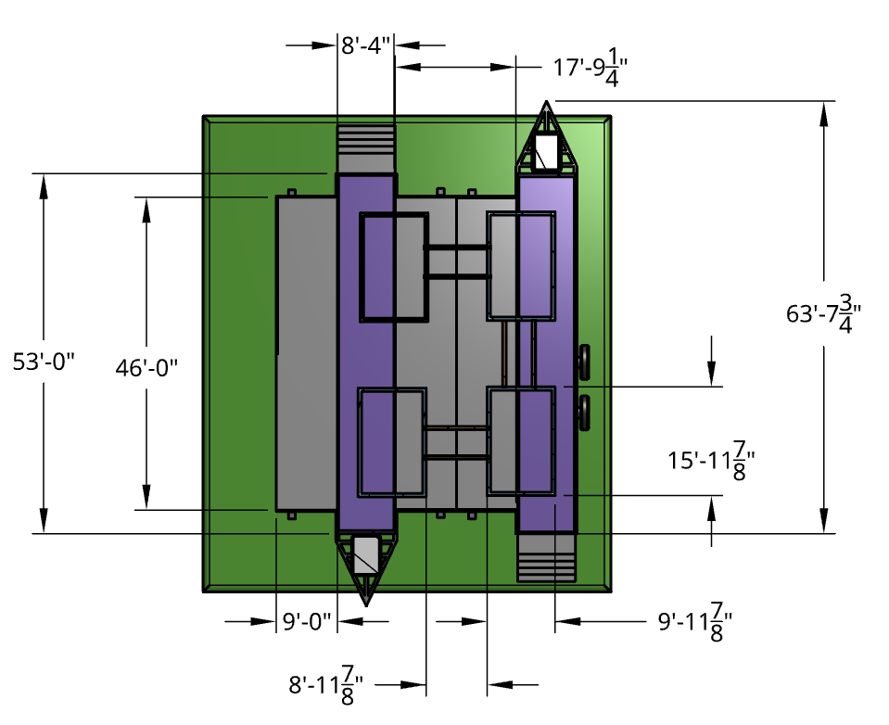

Figure 8: Overhead Section View with Dimensions